**PL_SQL APEX PRACTICE TRIGGERS**

- M. ROHITH

192324121

Write a code in PL/SQL to develop a trigger that enforces referential integrity by preventing the deletion of a parent record if child records exist.

Create departments table:

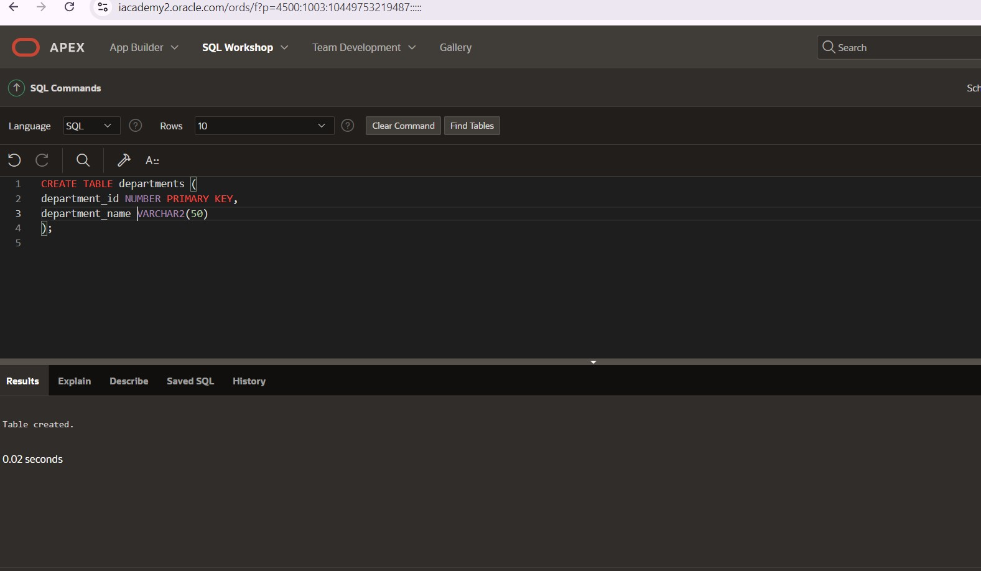

# Create the 'employeess’ table with a foreign key reference

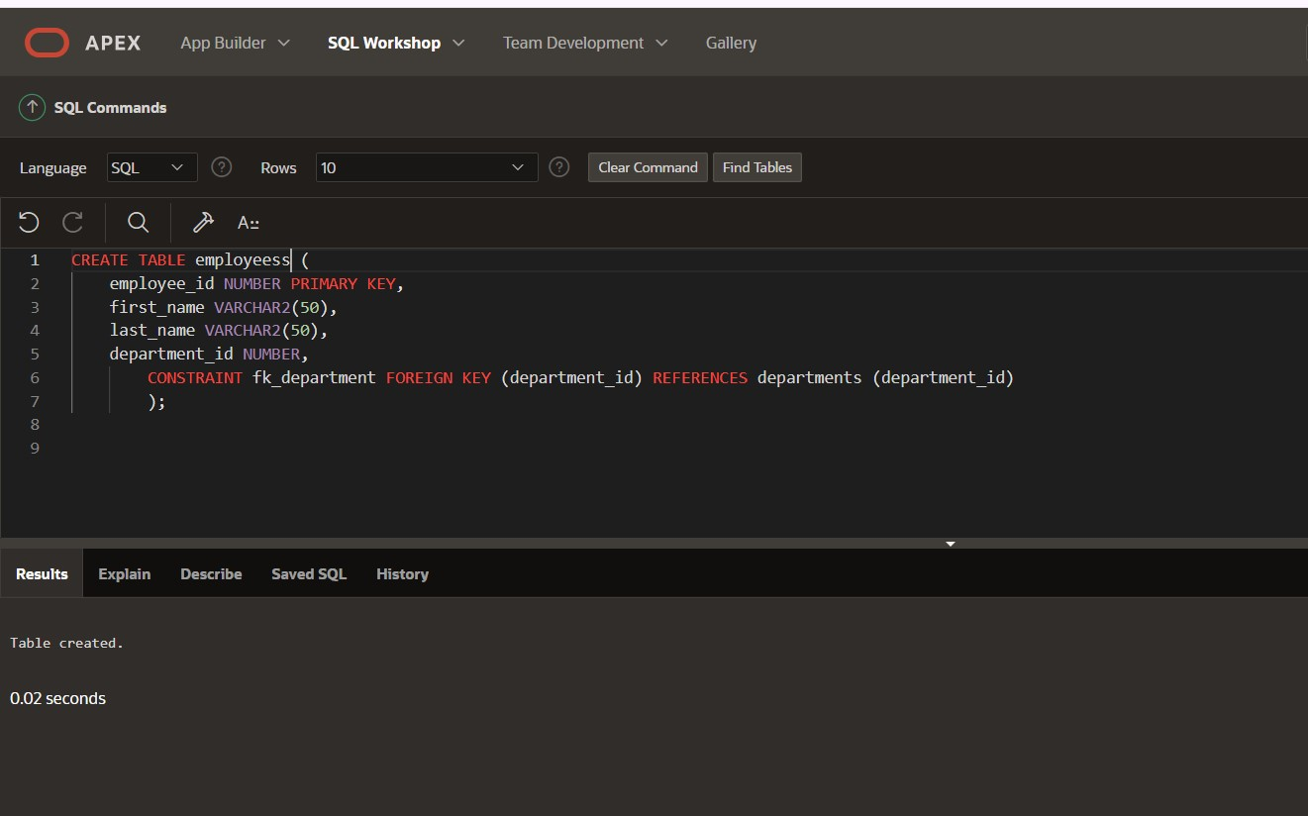

# Create a trigger to enforce referential integrity

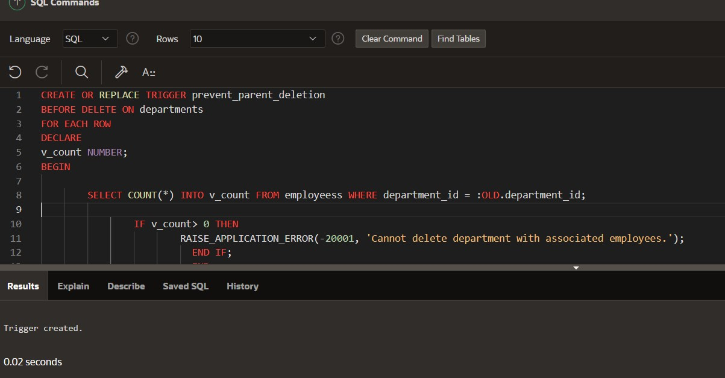

Write a code in PL/SQL to create a trigger that checks for duplicate values in a specific column and raises an exception if found.

# Add a column email to the employeess table

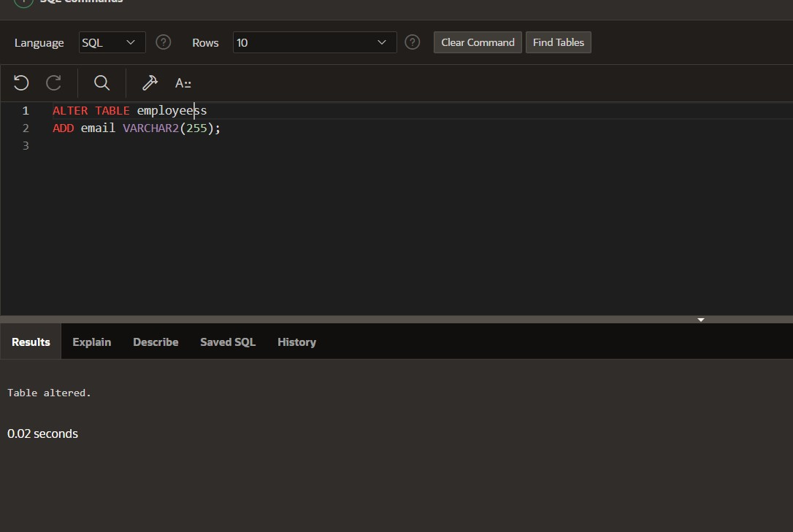

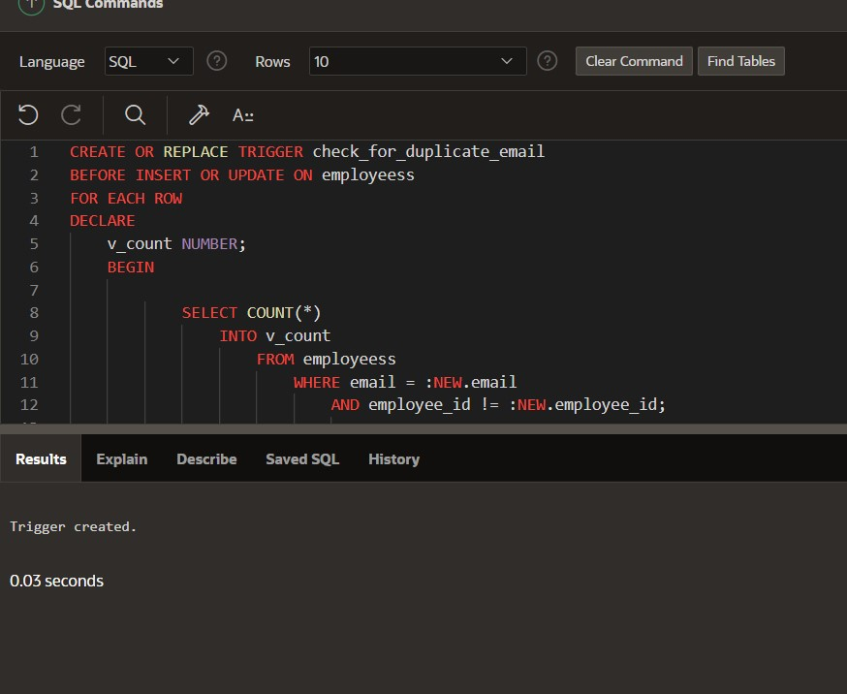

3rd

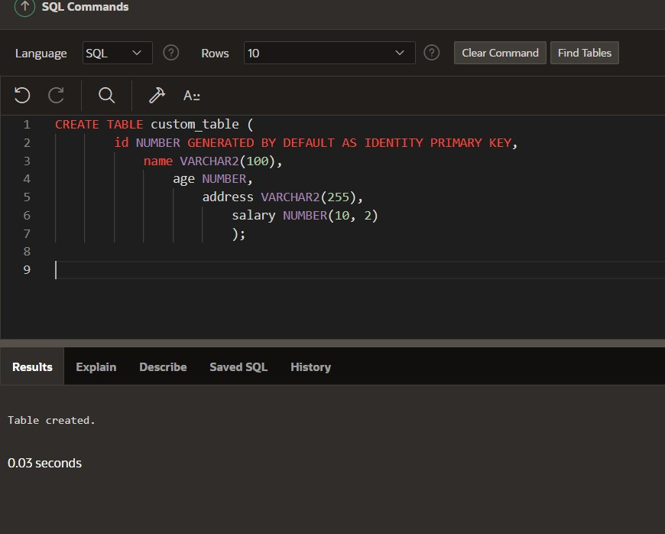

Exception handling

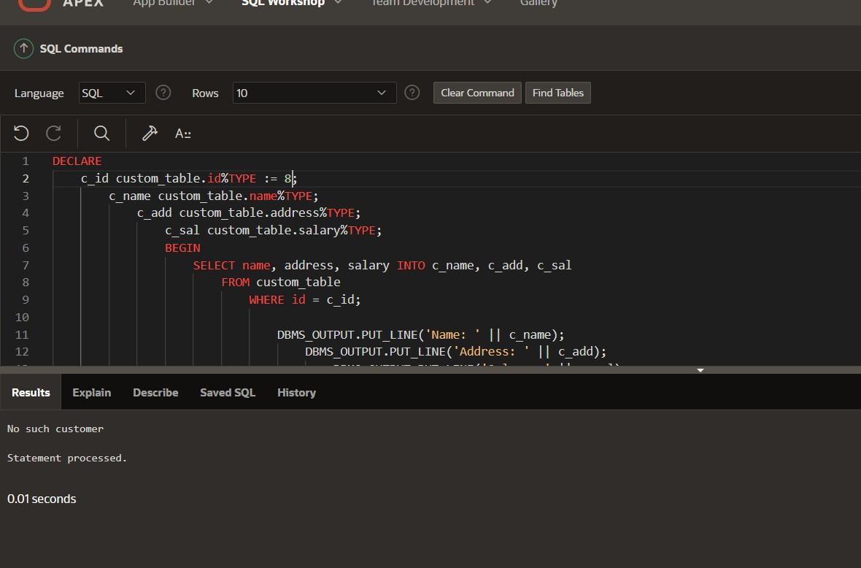

Write a PL/SQL block to handle the exception when a division by zero occurs

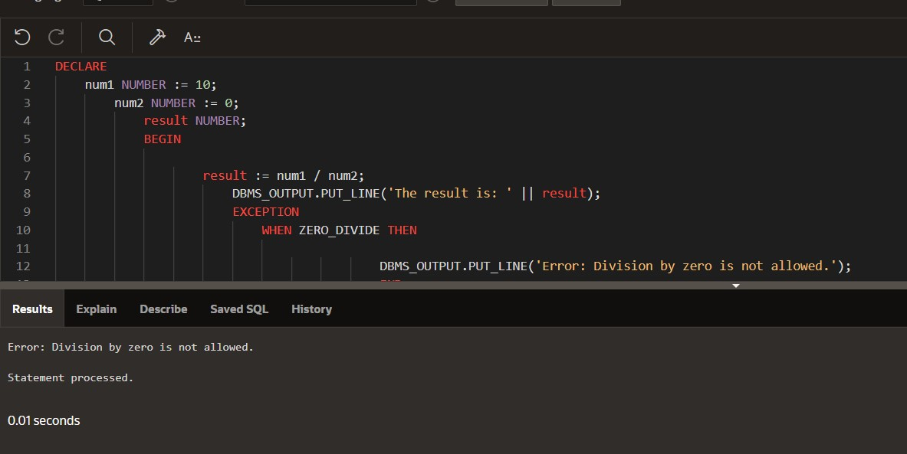

Handle the INVALID_NUMBER exception when converting a nonnumeric value to a number.

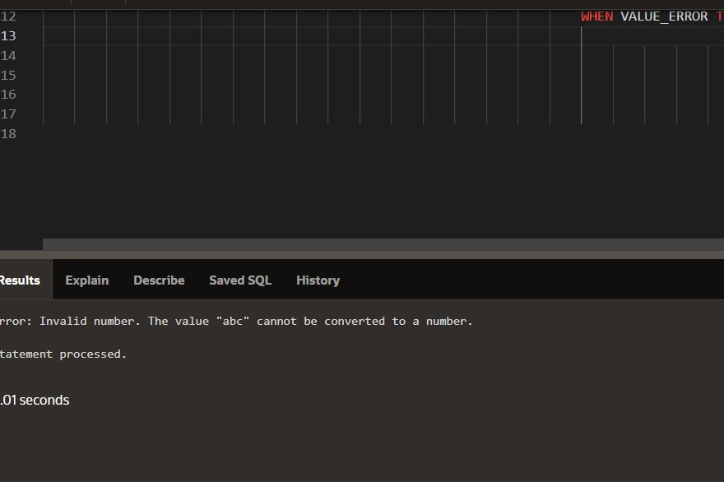

Handle the NO_DATA_FOUND exception when retrieving a row from a table and no matching record is found.

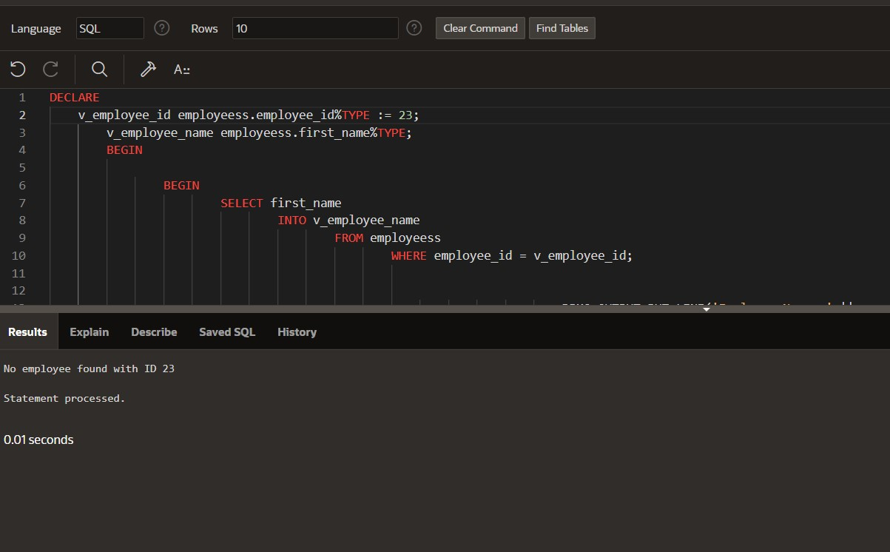

Handle the TOO_MANY_ROWS exception when retrieving multiple rows instead of a single row from a table.

